SPECIFICATION FOR APPROVAL

CUSTOMER : _______________________________________________

MANUFACTURER : __________________________________________

DESCRIPTION : _____________________________________________

MODEL : ___________________________________________________

PART NO : __________________________________________________

DATA : _____________________________________________________

MANUFACTURER |  | CUSTOMER

Test Report

Chapter 1. Main Designs ………………………………………………. 1-1
* On-Line Main Designs …………………………………………………………….. 1-1
* On-Line Main Designs 1 ………………………………………………………….. 1-2
* On-Line Main Designs 2 ……………………………………………………………... 1-3
* Block Diagram ………………………………………………………………………... 1-4

Chapter 2. Test Item ……………………………………………………… 2-1
* Specifications ………………………………………………………………………… 2-1
* AC line And Inv. Line Phase Assimilate ……………………………………………... 2-2
* Transient Response Test ……………………………………………………………… 2-3
* Harmonic Distortion ………………………………………………………………….. 2-4
* Harmonic Distortion (C-Load) ……………………………………………………….. 2-5
* Transfer Time Test 1 ………………………………………………………………….. 2-6
* Transfer Time Test 2 ………………………………………………………………….. 2-7
* Transfer Time Test 3 ………………………………………………………………….. 2-8
* Transfer Time Test 4 ………………………………………………………………….. 2-9
* Inverter Soft Start Test ………………………………………………………………. 2-10
* Over Load Test ……………………………………………………………………… 2-10
* Backup Time Test …………………………………………………………………… 2-11
* Whole Efficiency Test ………………………………………………………………. 2-12

Chapter 3. Troubleshooting ……………………………………………….. 3-1
* (A) Line LED doesn’t illuminates ……………………………………………………. 3-1
* (B) Inverter LED doesn’t illuminates ………………………………………………… 3-1
* (C) Load On Bypass LED illuminates ………………………………………………... 3-2
* (D) Fault LED illuminates ……………………………………………………………. 3-2
* The exterior structure and function ……………………………………………………3-3
* Quick Troubleshooting 1 ……………………………………………………………... 3-4
* Quick Troubleshooting 2 ……………………………………………………………... 3-5
* Quick Troubleshooting 3 ……………………………………………………………... 3-6
* Quick Troubleshooting 4 ……………………………………………………………... 3-7

- ON-LINE MAIN DESIGNS
There are mainly three major parts to perform the ON-LINE UPS FUNCTIONS, they are AC TO DC Converter, Battery Bank as well as DC to AC Inverter which are all shown as the drawing in the below:

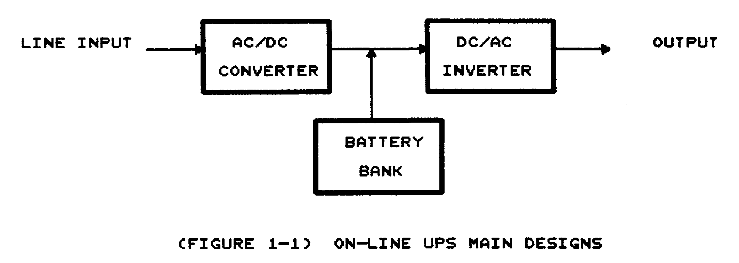

The figure above shows AC to DC Converter converts AC power into DC power and supplies power also to Inverter as well as to the Charger to proceed the charging to the batteries in the UPS.

Under normal operation status, the Converter supplies power to Inverter, whenever the AC Line fails, the Battery set will take the role to supply power to Inverter and output the requested Sine Wave to the Load side.

Page 1-1

More specifically, there are three respective drawings shown in the below can very clearly indicate how is the ON-LINE UPS really in operation modes. In Figure 1-2(a), the AC Line regularly supplies power to Converter, and then becomes Converter to supply power to Inverter, in the last is the Inverter supplies the power to the Load side. In the meantime, the charger is doing the charging into the Battery set. At the output sector, there is a Static Transfer Switch design to connect the Inverter with the Load, the Bold-faced line print in Figure 1-2(a) exactly shows this mode in operation.

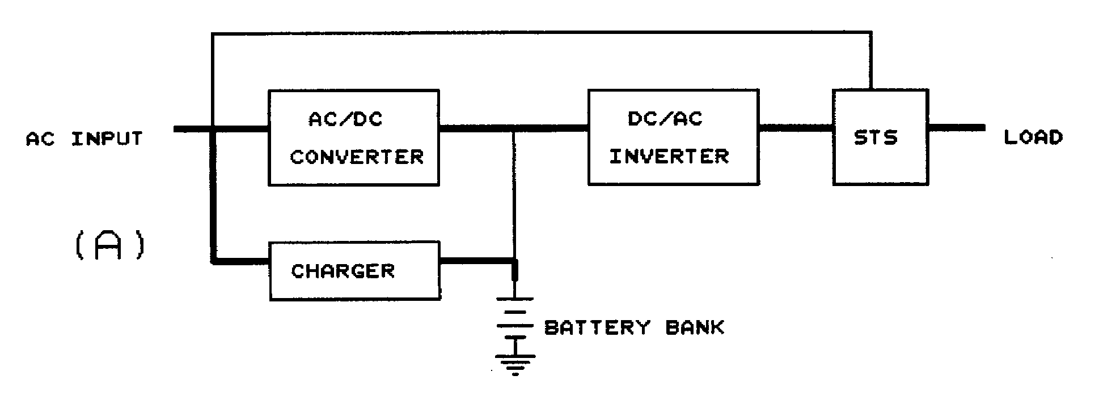

In Figure 1-2 (b), please refer to the Bold-faced line print, when AC Line fails, the Battery set will instantly back up the power to the Inverter and uninterruptedly output to the Load
side, the Load side actually will not be affected by the AC fails due to the Zero transfer time. The Battery set which supplies the power to Inverter will steadily keep its output to the Load side and will not be affected by the Battery set’s voltage level, only the back-up time will be descended in accords with the decrease of the discharging current. The back-up time is subject to Ampere Hour (AH) or Battery capacity.

Whenever the Inverter occurs an unexpected fails or having too much load, circumstances like this for a well-designed UPS, it must be capable to detect by its Auto-detect circuit device and instantly transfer to By-pass (AC Line) by Static Transfer Switch without any interruption, the operation mode is printed in Bold-face line as Figure 1-2 (c). The Inverter will get back in operation when its fault is precluded, until then, the Load side will be supplied by By-pass or to be shut down if AC Line fails at this very same time.

Page 1-2

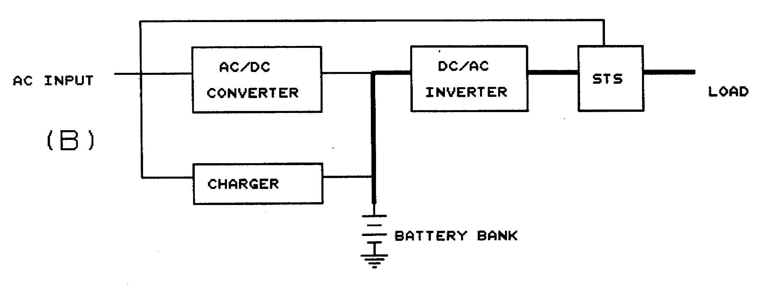

Figure 1-2(b)

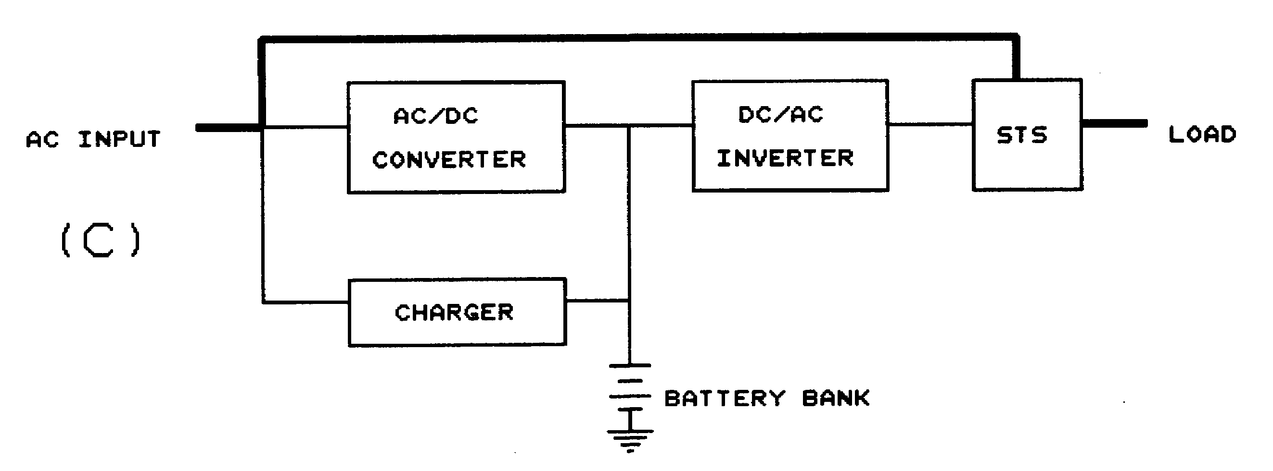

Figure 1-2(c)

Page 1-3
2.ON-LINE UPS’s STRUCTURE IN BLOCK DIAGRAM

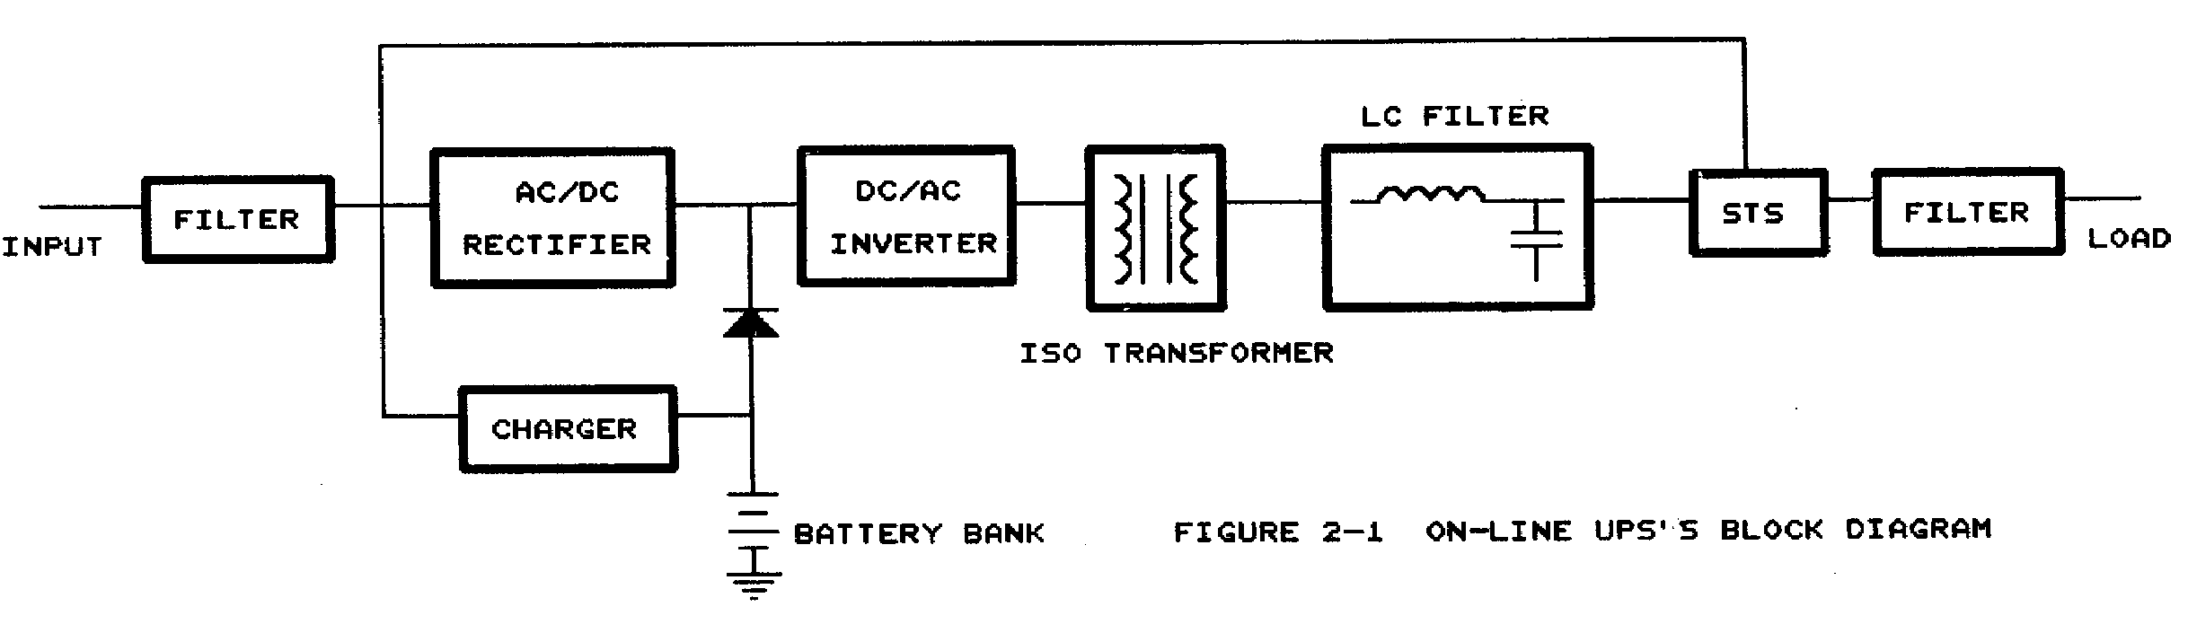

The ON-LINE UPS is a highly acclaimed reliable and intelligent designed UPS. The main features are such as:
- RECTIFIER: A Full-Bridge type rectifier to perform the filtering.
(2) CHARGER: For 3～8 K, the Charger Board is of Boost-Type. For 10～20 K the Charger Board is of Flyback-Type.
(3) BATTERY BANK: The whole ON-LINE UPS series is of 192 DCV, the battery capacity will be pertinently matched to the various models accordingly.
(4) INVERTER: The device of Inverter is of PWM 20KHZ Full-Bridge design with an Ultra Super Isolated Transformer added.
(5) STS(Static Transfer Switch): It is functioned by both Relay and TRIAC together.

To provide users the most considerate and convenience, there is a double display system design respectively LCD and LED to indicate a very comprehensive UPS operation mode status in case users are not available with soft ware application.

Page 1-4

TECHNICAL SPECIFICATIONS
GENERAL  Model | Standard | WL-1003 | WL-1004 |  | WL-1006 |  | WL-1008 |  | WL-1010 |  |  | WL-1012 |  | WL-1015 |  | WL-1020
GENERAL  Model | With LCD | WL-1003S | WL-1004S |  | WL-1006S |  | WL-1008S |  | WL-1010S |  |  | WL-1012S |  | WL-1015S |  | WL-1020S
GENERAL  Model | Capacity | 3KVA  2.1KW | 3.5KVA  2.45KW |  | 6KVA  4.2KW |  | 8KVA  5.6KW |  | 10KVA  7KW |  |  | 12KVA  8.4KW |  | 15KVA  10.5KW |  | 20KVA  14KW
INPUT | Voltage | 100V,110V,115V,120V,200V,220V,230V,240V±15％ |  |  |  |  |  |  | 190V,208V,220V,230V,240V,380V±15％
INPUT | Frequency | 50 or 60HZ±5％
INPUT | Phase | 1φ2ω+G |  |  |  |  |  |  | 1φ2ω+G or 3φ3ω+G or 3φ4ω+G
OUTPUT | Voltage | 100V,110V,115V,120V or 200V,220V,230V,240V
OUTPUT | Frequency Stability | ±0.5％(Free running)
OUTPUT | Voltage Regulation | ±1％ |  |  |  |  |  |  | ±1％(±3％with ISO Transformer)
OUTPUT | Transient Response | ±5% ( 100% load change)
OUTPUT | THD | 3%(Linear Load)
OUTPUT | Wave form | Sine-Wave
OUTPUT | Overload Capacity | 105% ~150% for 30 seconds,>150% for 10 cycle
OUTPUT | Short circuit | Auto cut off output no transferring to bypass
OUTPUT | Crest Factor | 3:1
OUTPUT | Transfer Time | Zero-cross transfer,<2 ms. UPS to bypass or reverse
OUTPUT | Efficiency | ≧83%
BATTERY | Battery Type | Lead acid maintenance-free battery
BATTERY | Battery Type | 12V4Ah  x 16pcs |  | 12V5Ah  x 16pcs |  | 12V7Ah  x 16pcs |  | 12V8Ah  x 16pcs |  | 12V8Ah  x 16pcs | 12V12Ah  x 16pcs |  | 12V12Ah  x 16pcs  x2sets |  | 12V12Ah  x 16pcs  x2sets
BATTERY | Battery Voltage | 192V
BATTERY | Back up Time(Full) | 8mins | 6mins |  | 6mins |  | 5mins |  | 5mins |  |  | 4mins |  | 9mins |  | 5mins
BATTERY | Recharge Time | 5 hours to 90% |  |  | 8 hours to 90%
INTERFACE | Communication | RS232/Dry Contact or AS 400(option)
INDICATOR | LED | Line(green),inverter(green),bypass(orange),battery(green),fault(red),overload(orange),  Over charge(orange),battery level(5 LED indicators)
INDICATOR | LCD | System operating status display,input/output voltage,frequency,output loading%,battery voltage,temperature ℃
Audible Alarm | Utility Power fail | Beeping every 4 seconds approx. 2 minutes auto alarm reset
Audible Alarm | Low Battery | Rapid beeping every second as battery approaches final discharge
Audible Alarm | Fault Over Charge | Continuous
Audible Alarm | Overload | Beeping 2 seconds on every other second
APPEARANCE | Dimension(W*D*H-mm) | 235*585*620 |  |  | 265*634*735 |  |  |  | 353*930*1017
APPEARANCE | Weight(KG) | 80 | 88 |  | 130 |  | 140 |  | 222/228 |  |  | 234/303 |  | 320/410 |  | 336/436
ENVIRONMENT | Audible Noise | <50dB |  |  |  |  |  |  | <60dB
ENVIRONMENT | Operating Temperature | 0℃To 40℃
ENVIRONMENT | Humidity | 0%~90%(non-condensing)

Page 2-1

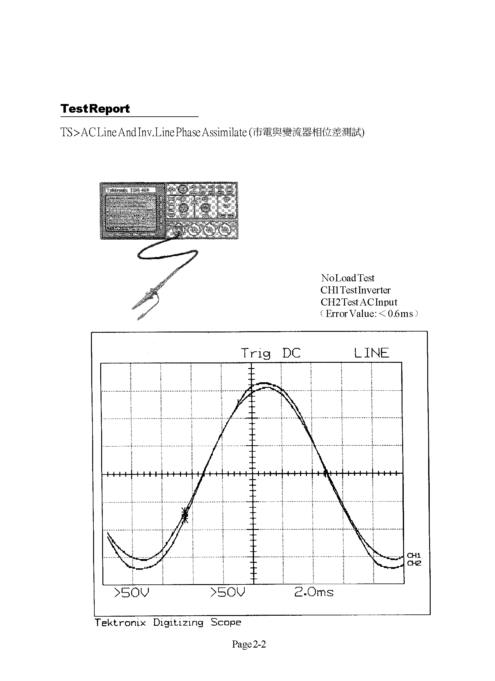
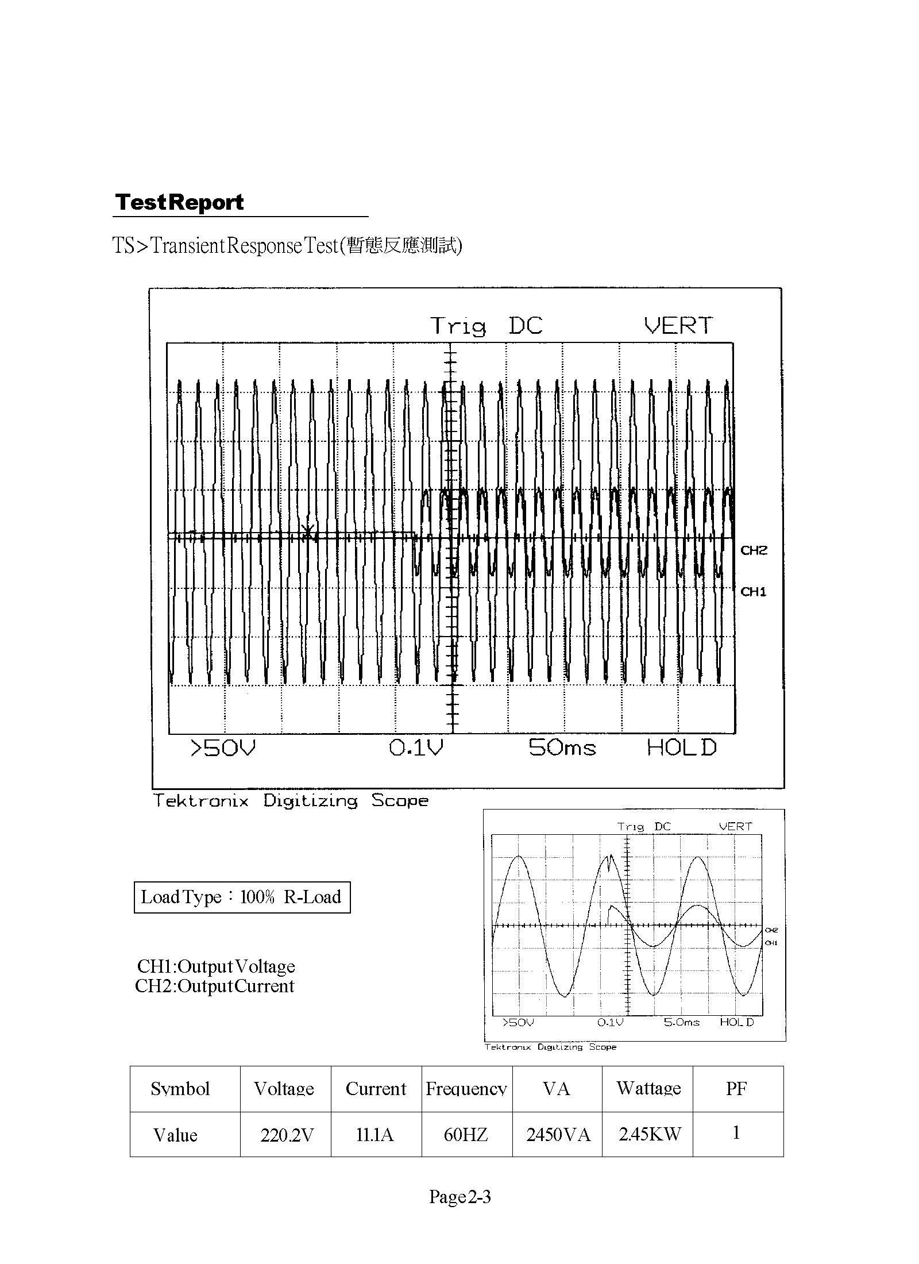
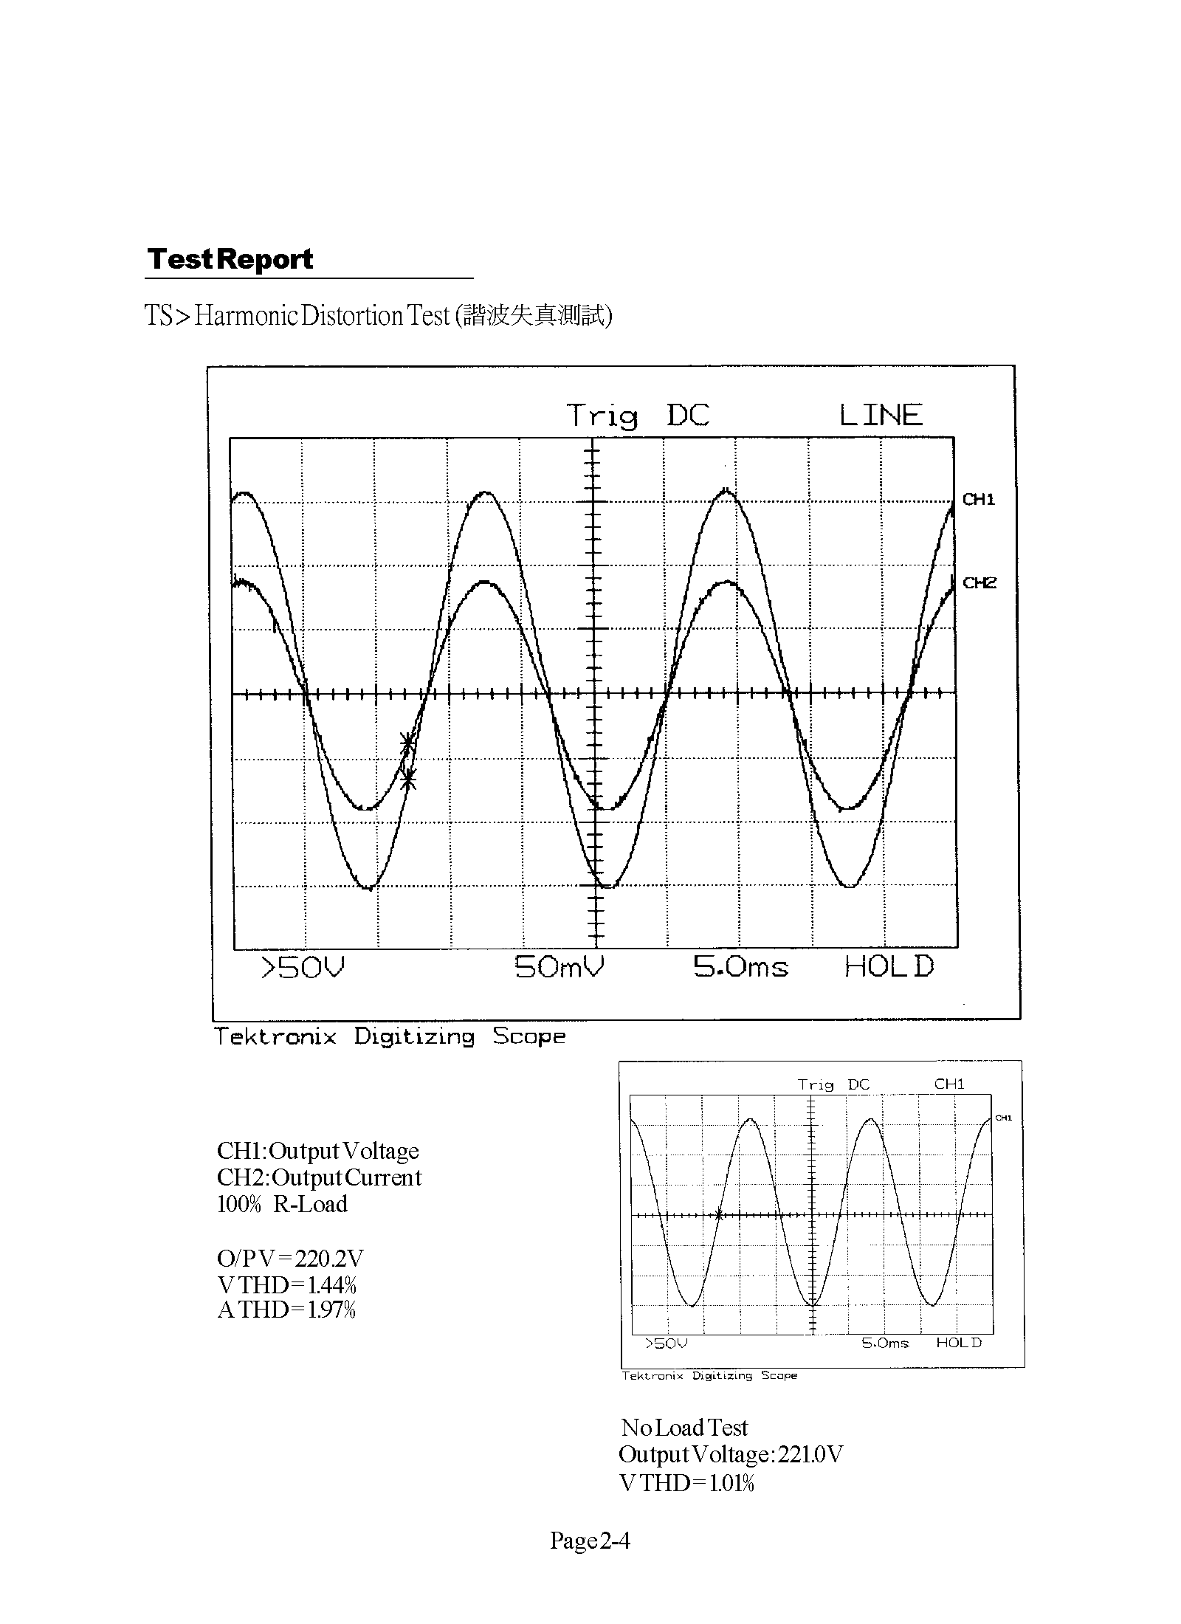
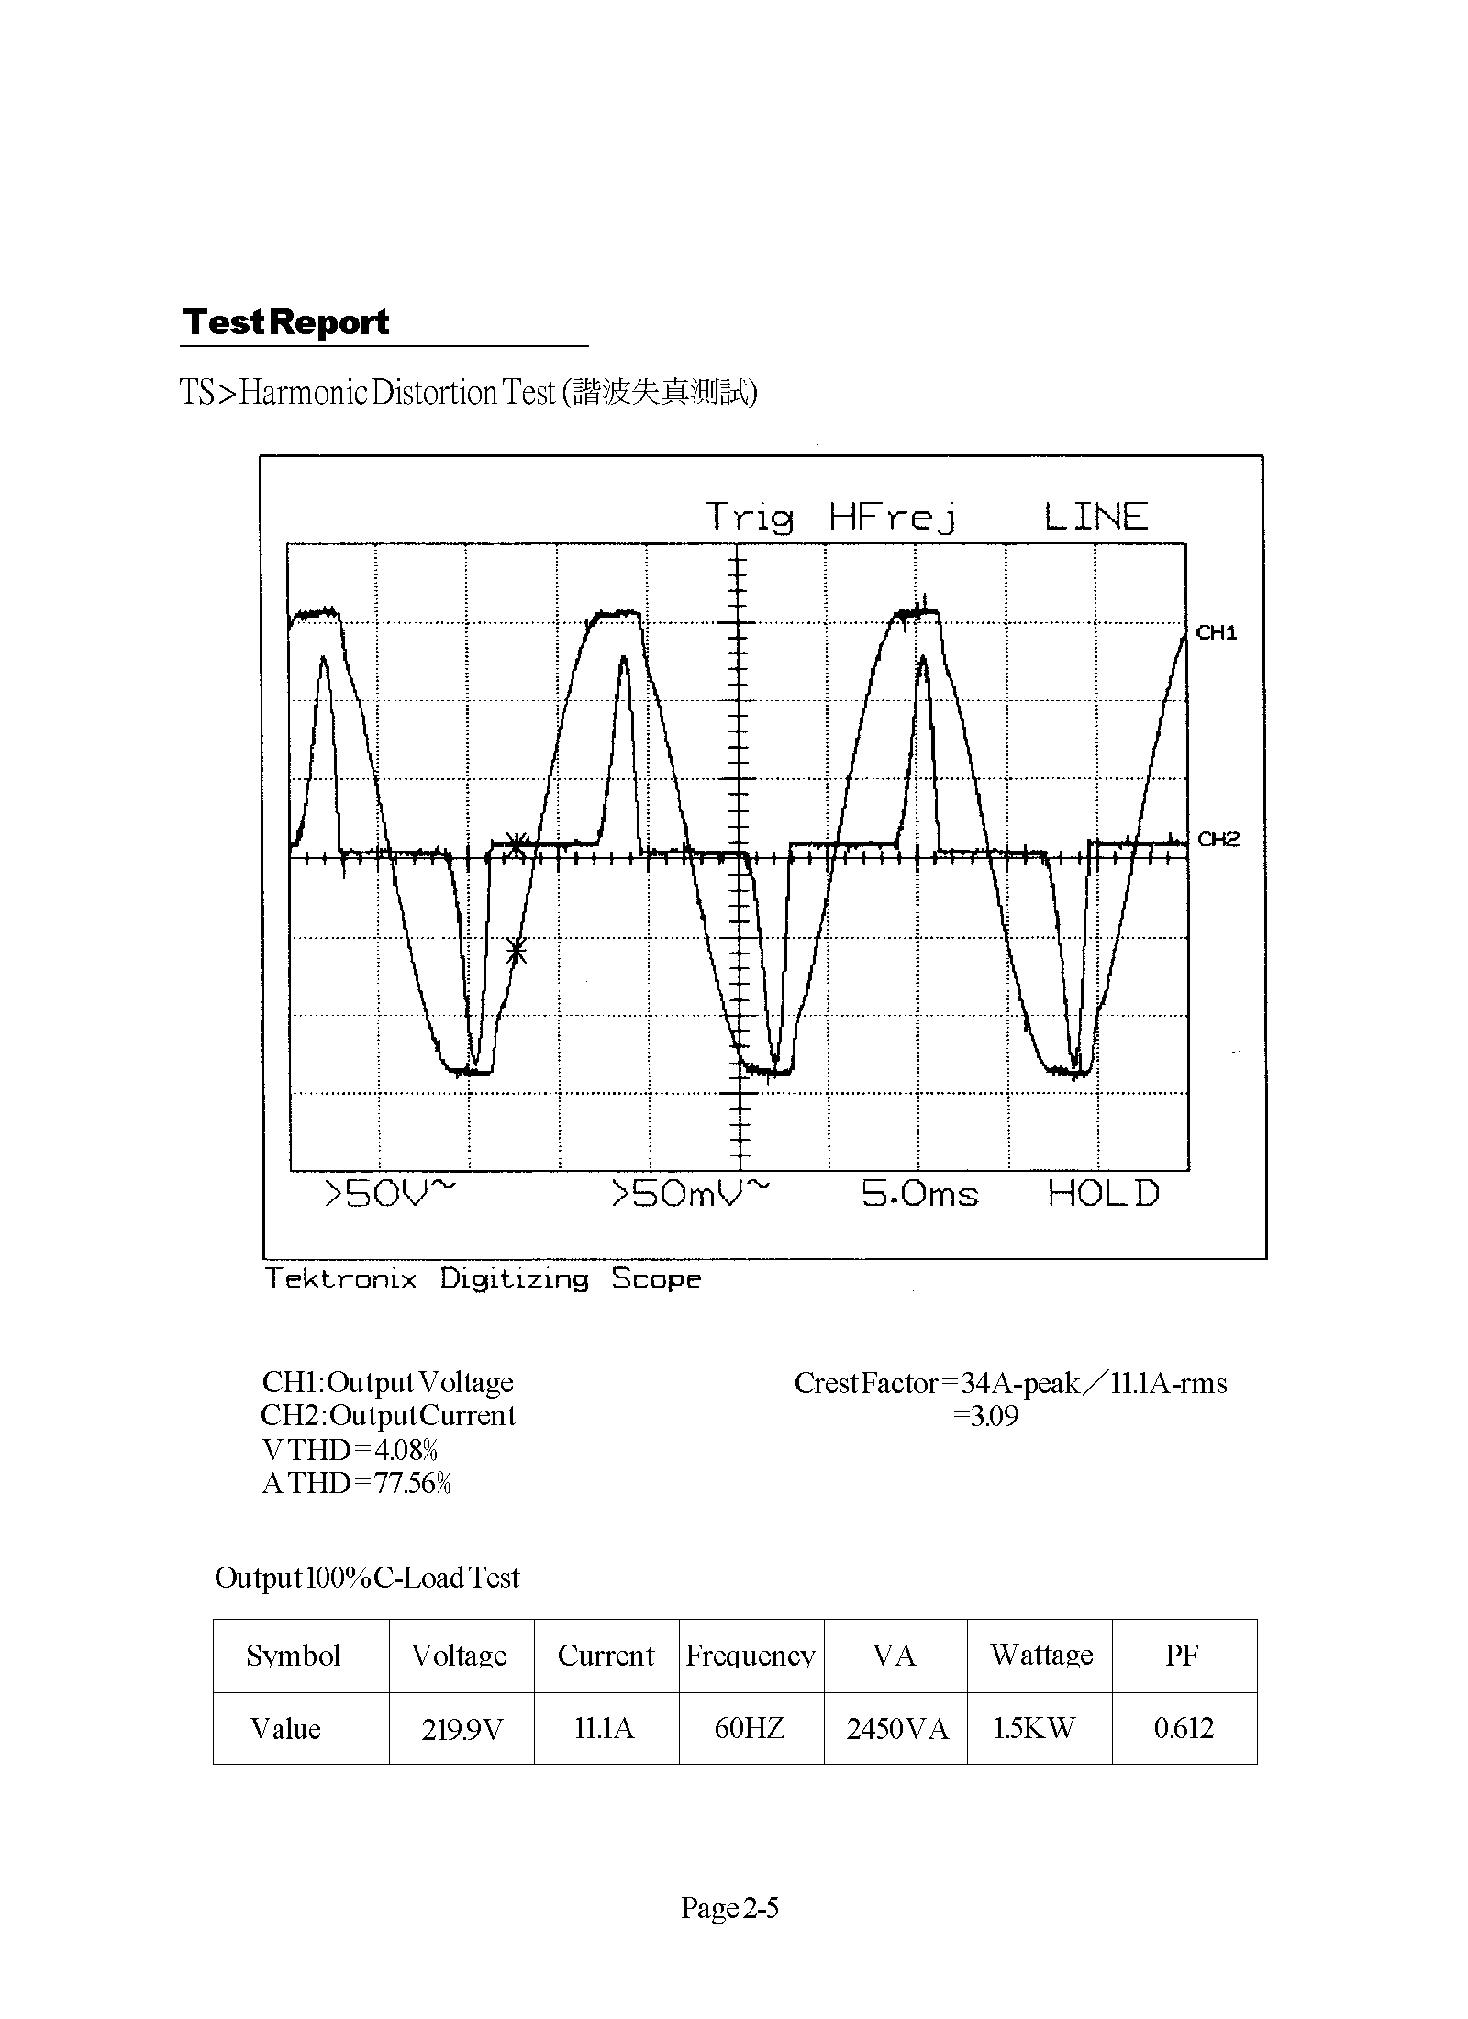
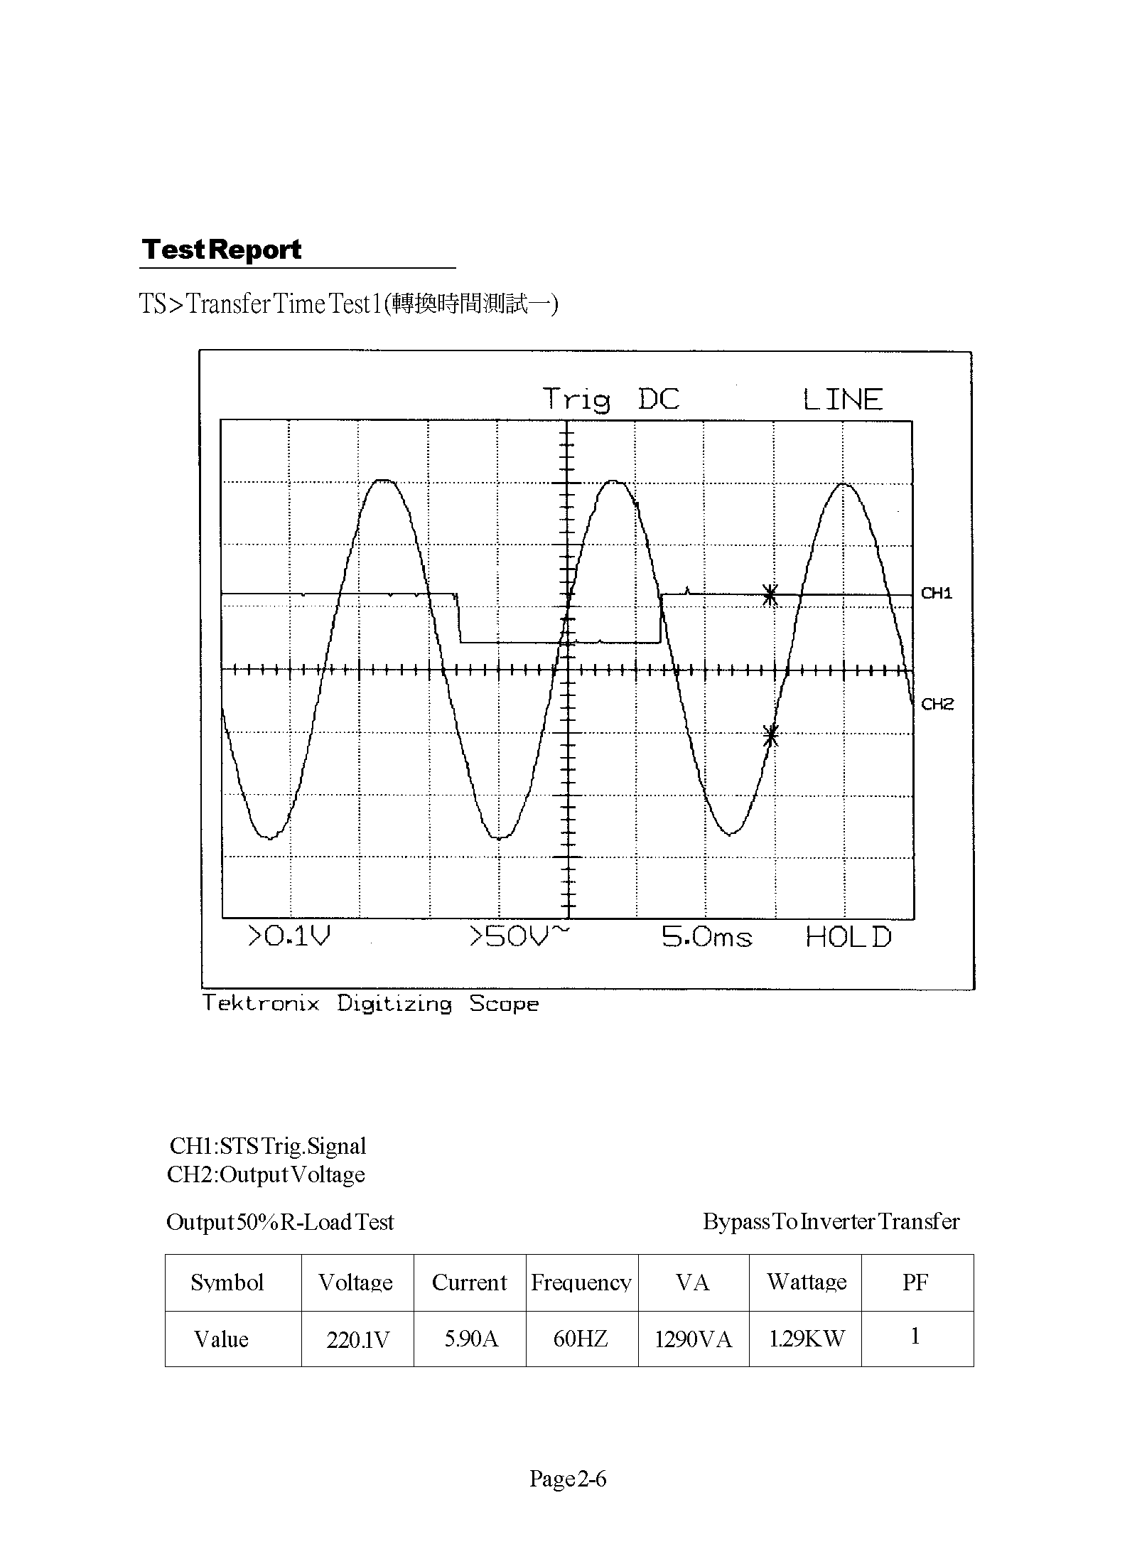
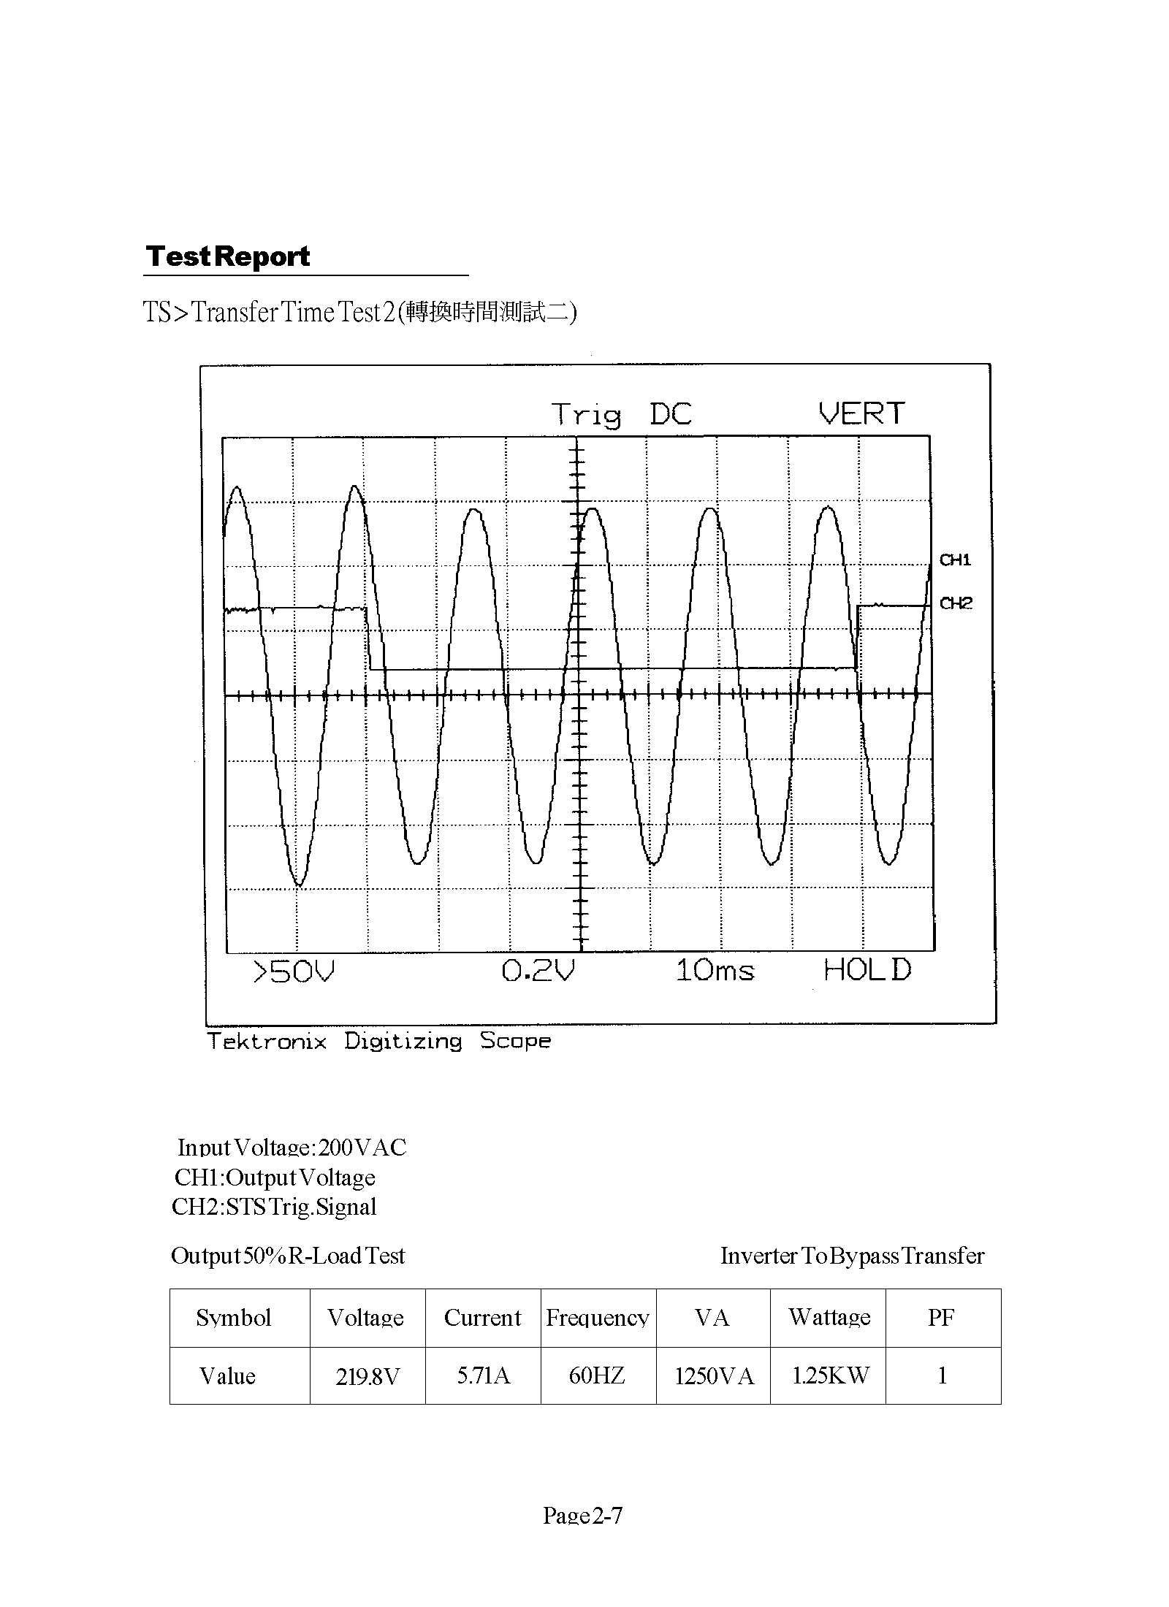
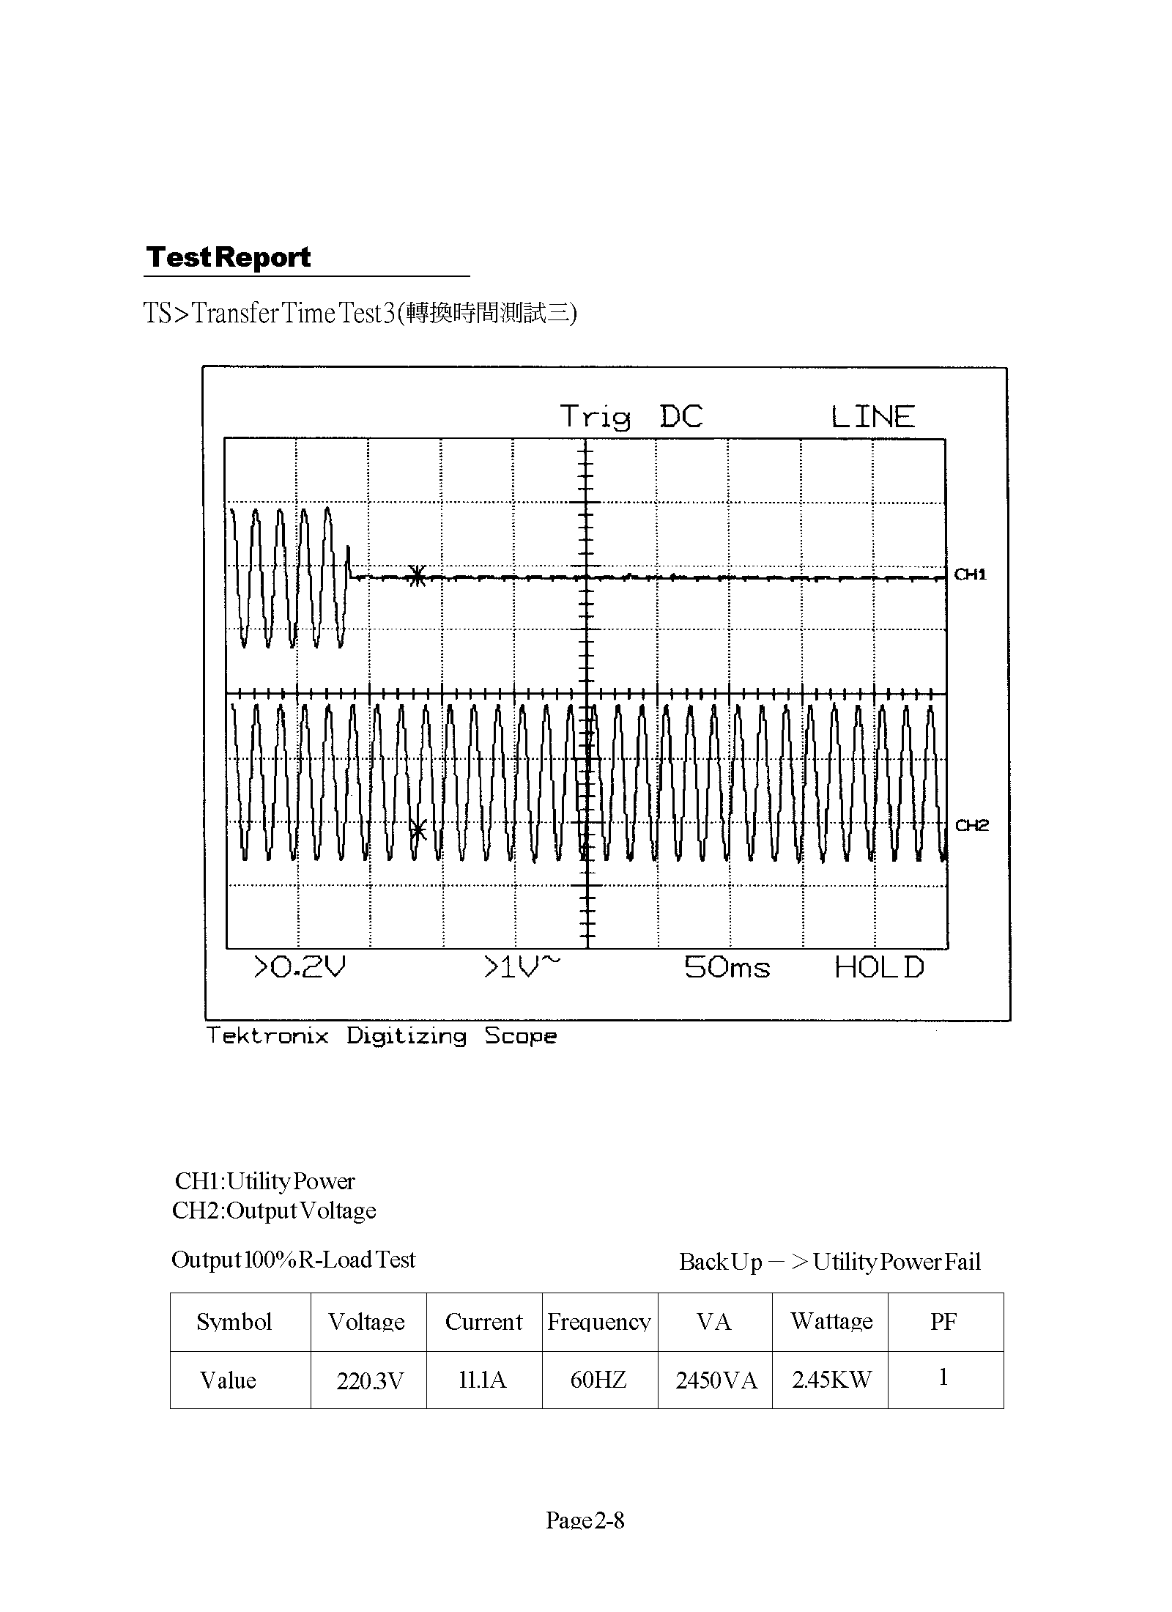
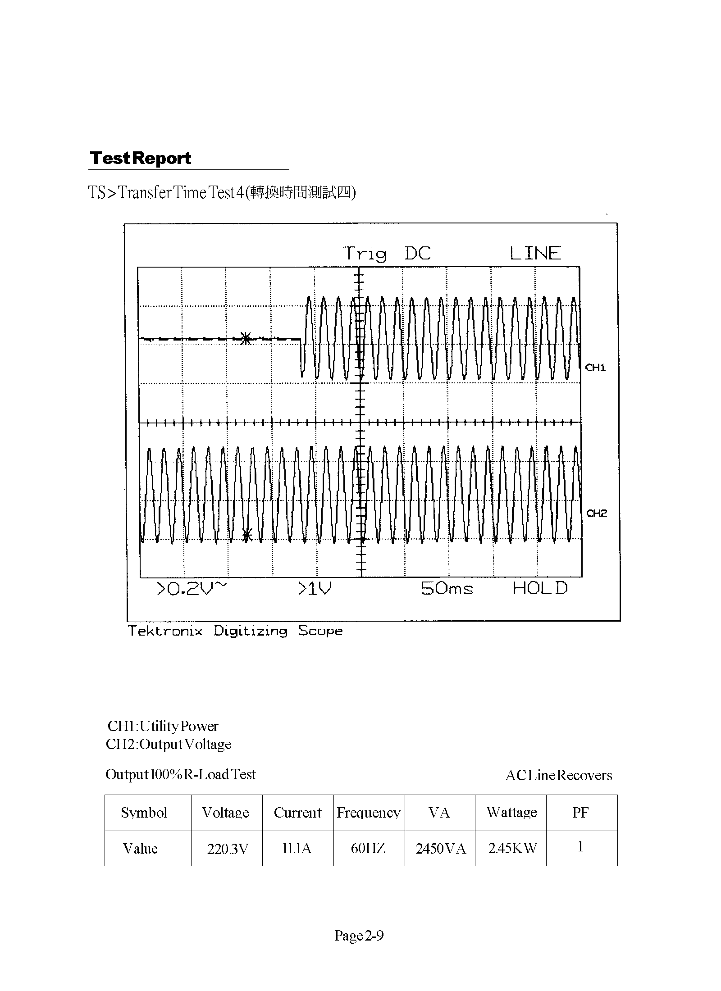

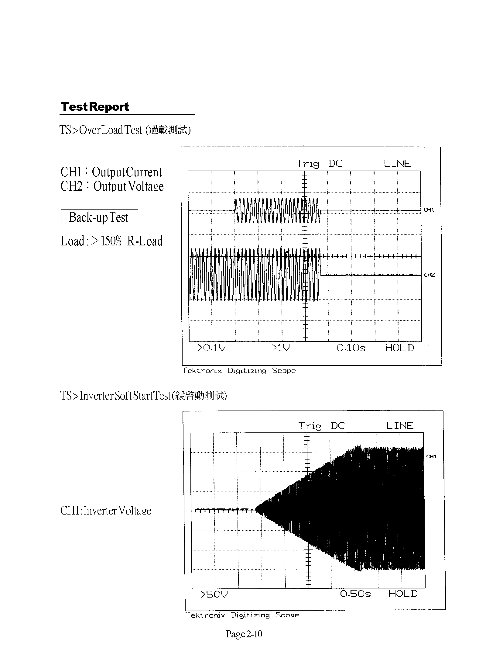

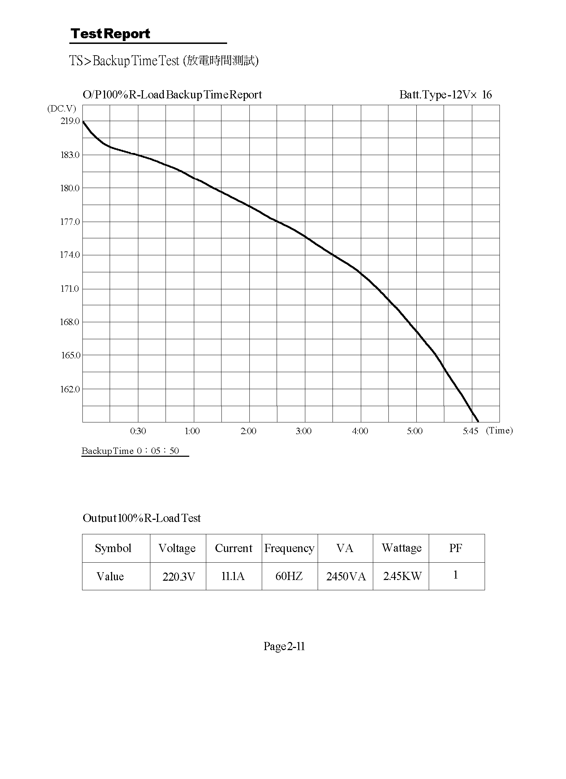
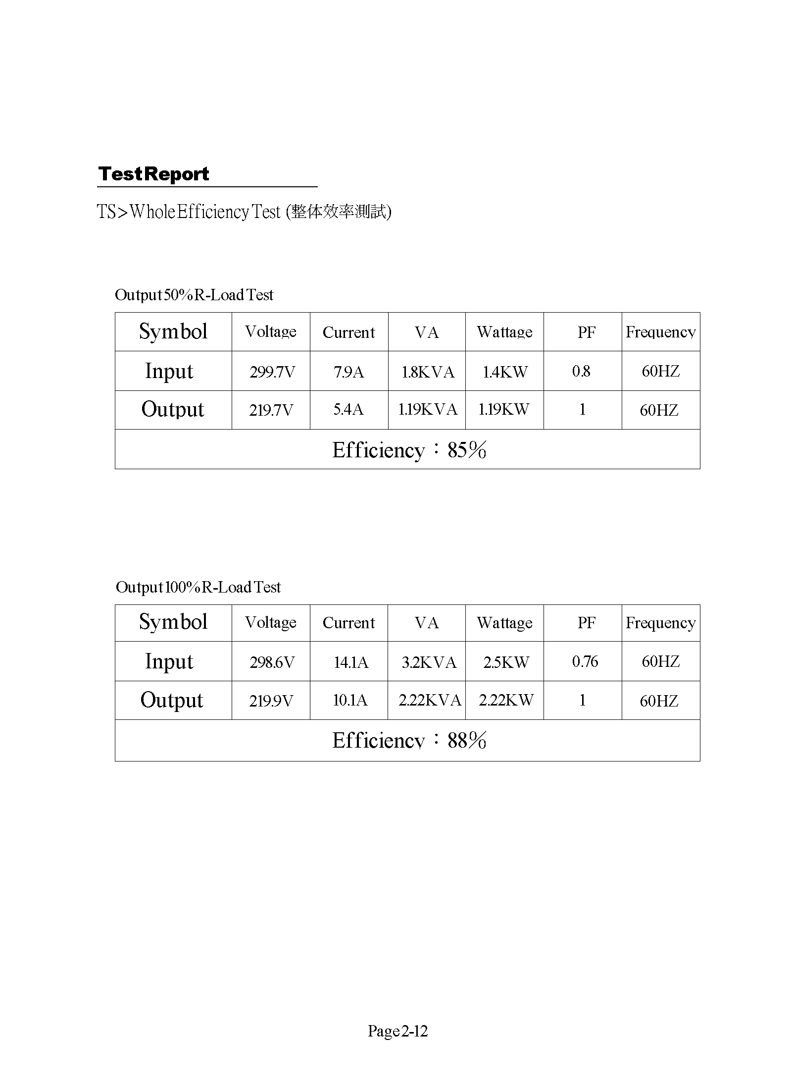

The exterior structure and functions

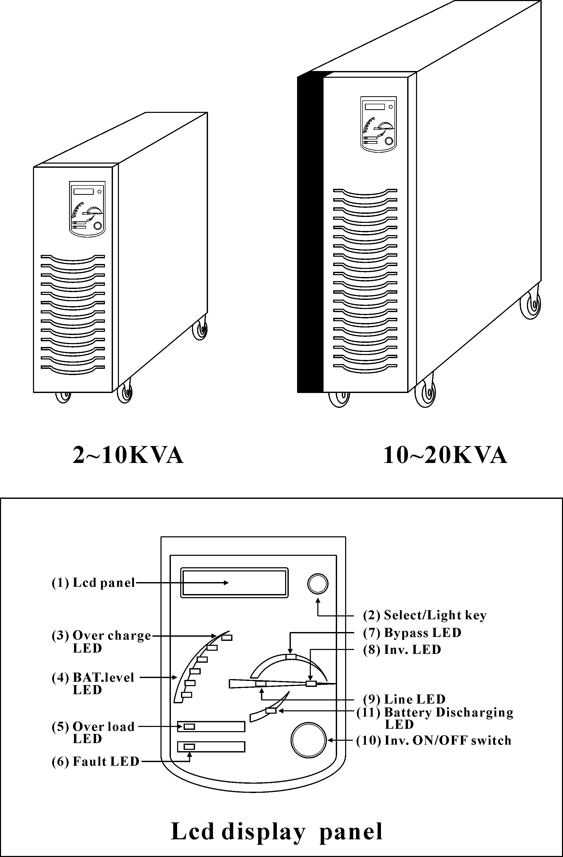

Page 3-
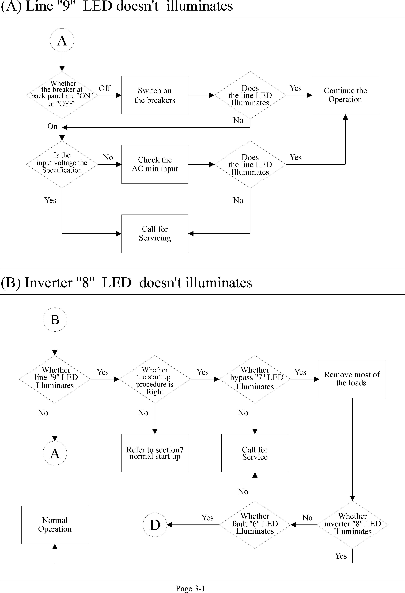
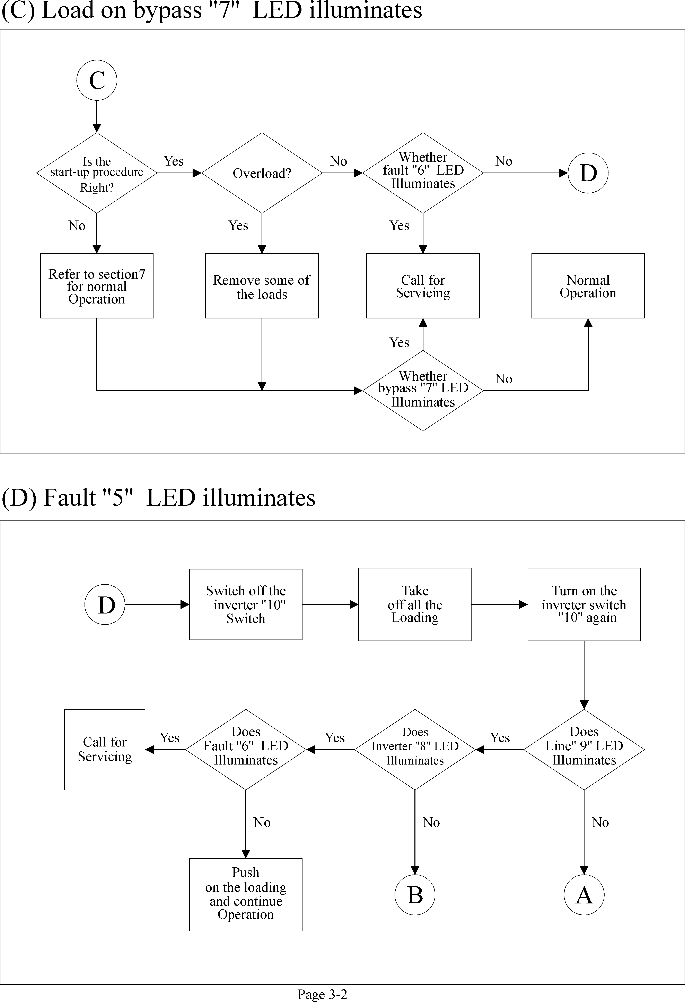
Quick Trouble-Shooting

Trouble Ⅰ.UPS Main switch in the rear Trip
Possible Cause: UPS Bridge burned
Action to take: Replace Bridge Rectifier (for instance, The Bridge
Rectifier of WL-1006S IS 6RI100E-080)

Trouble Ⅱ.No INV INDICATOR LIGHT, COOLING FAN NOT WORKING, FAULT INDICATOR LIGHT ON, ALARM LONG BEEPING, BUZZER ALARM INSTANTLY AFTER RE-SET INV

Possible Cause: Control Board NS-CNTL-101 (CNTL-232) DC voltage feedback abnormal
Action to take: Replace NS-CNTL-101,R6 100KΩ/2W(CNTL-232,R16)

Trouble Ⅲ.No INV INDICATOR LIGHT, COOLING FAN NOT WORKING, FAULT INDICATOR LIGHT ON, NO ALARM BEEP, NO BAT LEVEL INDICATOR LIGHT, REMAINS THE SAME AFTER RE-SET INV
Possible Cause: There is no +12V DC voltage the Control Board NS- CNTL-101 (CNTL-232)
Action to take:1.Check the Charger (NS-CHGR2 or F804M-01-A) and see if there is DC 219V output or not ？If no, change the Charger fuse or the Charger
2.If there is DC 219V output in the Charger, then please check the Control Board NS-CNTL-101 (CNTL-232) and see if there is DC 12V among CN3,PIN9,PIN10？Also, see if there is DC 23V between PIN 8 and PIN 10 ？
3.If there is no DC 23V between PIN8 and PIN10,please check CN1 in the Driver Board (NS-PSDR-102) and see if there is DC 219V？If there is, then please check the Diode D1 and the Resistors of R1,R2 (10Ω/5W),R3,R4, R5,R6,R7(1.8K/3W)see if any burns？
4.If there is no DC 219V in CN1, please check DC Magnetic Contractor’s coil or Diode (IN4007) in the coil burned？
5.Check and see if the INV switch in the panel is burned？

Page 3-4

Trouble Ⅳ.LINE INDICATOR LIGHTS ON, BYPASS INDICATOR LIGHTS ON, NO INVERTER INDICATOR LIGHT, COOLING FAN NOT WORKING, FAULT INDICATOR LIGHTS ON, LONG BEEPING ALARM, AFTER RE-SET INVSWITCH 1～2 SECONDS THERE IS FAULT INDICATOR LIGHTS ON ALONG WITH LONG BEEPING ALARM.
Possible Cause: Inverter Fault.
Action to take : Disconnect the Fast Fuse first and soon and then use Scope to check the Driver Board (NS-PSDR-102) to see the wave forms of TP 16-R57, TP12-R53, TP7-R53, TP2-R51 are normal or abnormal？It should have a step wave form with. +15V, -5V.If any of them is abnormal, PLEASE check the very IGBT which the abnormal waveform is connected to. Replace the burned IGBT. Re-check four waveforms one more time, if all four are normal, switch off the INV switch and re-connect the Fast Fuse. If the waveforms are still not normal, then replace the Driver Board (NS-PSDR-102) or even the Control Board NS-CNTL-101 (CNTL-232)
NOTE: UNDER NORMAL CONDITION, THE INV INDICATOR WILL SLOWLY LIGHT ON AND COOLING FAN WILL START TO WORK WHEN INV IS SWITCHED ON.

Trouble Ⅴ: LINE INDICATOR LIGHTS ON, BYPASS INDICATOR LIGHTS ON, NO INVERTER INDICATOR LIGHT, COOLING FAN NOT WORKING, FAULT INDICATOR LIGHTS ON, LONG BEEPING ALARM, AFTER RE-SET INV SWITCH 22 SECONDS LATER, THERE IS FAULT INDICATOR LIGHTS ON ALONG WITH LONG BEEPING ALARM.
Possible Cause: Inverter NOT Working.
Action to take : Same as Trouble Ⅳ, the only difference is it takes 22 seconds to light on Fault Indicator. This clearly shows the Fast Fuse is burned, Replace the Fast Fuse.

Page 3-5

Trouble Ⅵ.LINE INDICATOR LIGHTS ON, BYPASS INDICATOR LIGHTS ON, NO INVERTER INDICATOR LIGHT, COOLING FAN NOT WORKING, NO FAULT INDICATOR, BAT LEVEL INDICATOR IS NORMAL (BUT INV IS NOT WORKING).
Possible Cause: Over load or Control Board NS-CNTL-101 (CNTL-232) is abnormal.
Action to take: 1.Remove some load away, INV will light on and cooling fan will also start to work and all back to normal. If it is not back to normal, please check the Resistors R191, R192 (R208) on the Control Board NS-CNTL-101 (CNTL-232) and the CT which connected with CN8, are they burned？Replace them, if yes.
2.If UPS is tripping between INV and BYPASS, it also shows Over load, please remove some load away.
3.If there is no load, but UPS is also tripping between INV and BYPASS, please check the TRIAC on the Control Board NS-CNTL-101 (CNTL-232) see if it is burned？
Trouble Ⅶ.WHEN UPS IS NORMALLY ADDING LOAD BEGINNING FORM NO LOAD, UPS FAULT INDICATOR LIGHTS ON AND LONG BEEPING ALARM.
Possible Cause:1. Charger fault or Battery is getting to pre-set low BAT LEVEL
2. CN6 DC feedback voltage on the Control Board NS-CNTL-101 (CNTL-232) is too high.
Action to take: 1.Use Multi-meter checks UPS’s output terminal, if there is 219V
between B+ and B- or not？Normally there should be voltage a little bit less than 219V between B+ and B-. Replace the Charger if it is fault.
2.Please check the Control Board’s NS-CNTL-101 (CNTL-232) CN6 see the feedback Resistor R35 is burned or not？

Trouble Ⅷ.UPS IS NORMAL BUT IT IS FAULT RIGHT AFTER THE AC FAILS
Possible Cause: Battery fault
Action to take: 1.Check the Charger voltage first. If it is normal, it must be the is fault. Replace the Battery.
2.If the Battery is inflated, it shows the Battery is overcharged. Please check the Charger’s voltage see if it is too high？also check the three phase Bridge Rectifier see if it is burned？

Page 3-6

Trouble Ⅸ.UPS IS NORMAL AND ALSO CAN NORMALLY WORK AFTER THE AC FAILS, BUT UPS WILL BECOME FAULT AND LONG BEEPING ALARM WHEN AC RECOVERS.
Possible Cause: Please check the Control Board’s CN-CNTL-101 (CNTL-232) CN6 see the DC CT’s feedback voltage is too high or not？or is its phase failure？
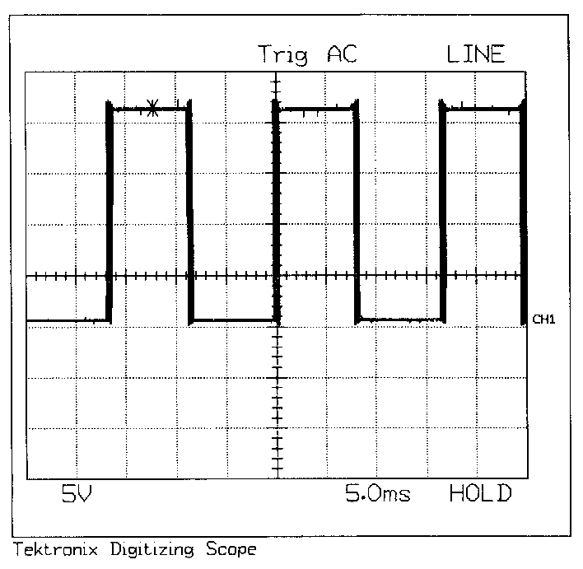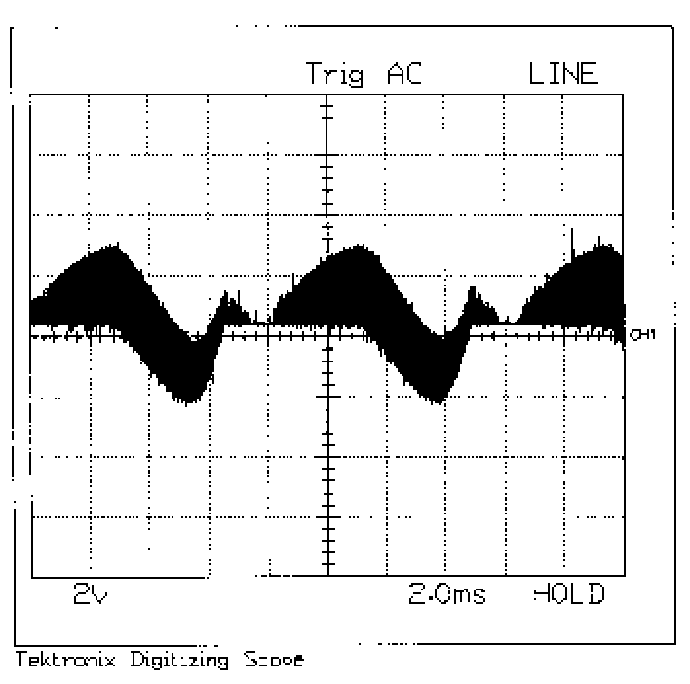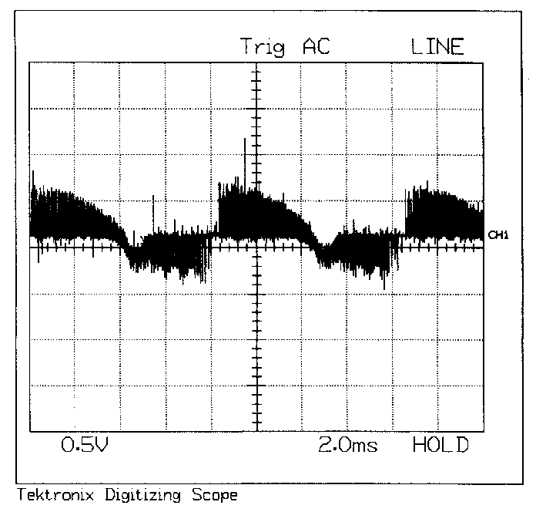Action to take :1.Please check the Control Board’s CN-CNTL-101 (CNTL-232) R35 (R33) see if it i DC C burned？
s burned？or
Page 3-7

Wave form of IGBT G-E

TP16,TP12,TP7,TP2
Wave form of no load,
NS-CNTL-101 (CNTL-232),
CN6-DC-CT-R35(R33)
TP024 => 0V, (TP2 => 0V)

Full load
NS-CNTL-101 (CNTL-232),

CN6-DC-CT Wave form
R35(R33),TP024 => 0V (TP2 => 0V)

